***PRACTICAL ASSIGNMENT***

***CLASS : BCA (AIML)B***

***NAME = Mukesh dagar***

***GROUP 2***

***Q 1= Create a simple html tag using basic tags?***

***<HTML>***

***<HEAD>***

***<TITLE> HELLO WORLD </TITLE>***

***</HEAD>***

***<body>***

***<H1> Your Name </h1>***

***</Body>***

***</html>***



***Q2- Create a webpage that displays your name to the screen?***

***<HTML>***

***<HEAD>***

***<TITLE> HELLO WORLD </TITLE>***

***</HEAD>***

***<body>***

***<H1> Mukesh dagar</h1>***

***</body>***

***</html>***

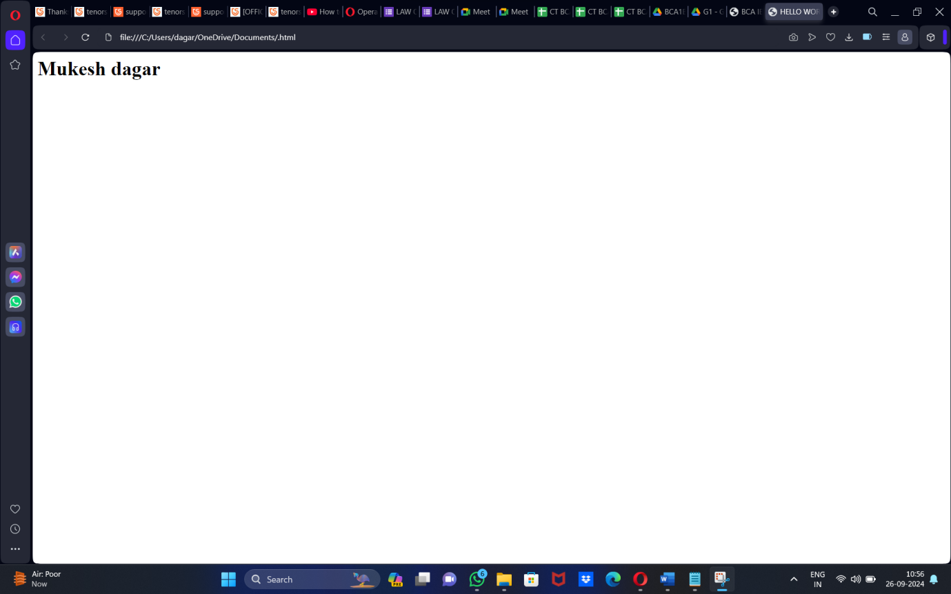

***=Output***

***Q3- Create a web page and show the output from 1 to 10***

***<HTML>***

***<HEAD>***

***<TITLE> HELLO WORLD </TITLE>***

***</HEAD>***

***<body>***

***1<br> 2<br> 3<br> 4<br> 5<br> 6<br> 7<br> 8<br> 9<br> 10<br>***

***</body>***

***</html>***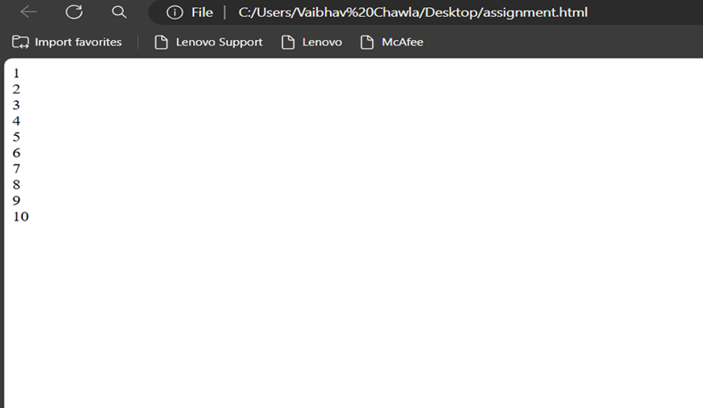

***Q4- Create a webpage and show the output from 1 to 10 in seprate lines , each number being in different color?***

***<HTML>***

***<HEAD>***

***<TITLE> HELLO WORLD </TITLE>***

***</HEAD>***

***<body>***

***<font color="red"> 1 </font><br>***

***<font color="blue"> 2 </font><br>***

***<font color="green"> 3 </font><br>***

***<font color="black"> 4 </font><br>***

***<font color="brown"> 5 </font><br>***

***<font color="pink"> 6 </font><br>***

***<font color="orange"> 7 </font><br>***

***<font color="purple"> 8 </font><br>***

***<font color="grey"> 9 </font><br>***

***<font color="yellow"> 10 </font><br>***

***</body>***

***</html>***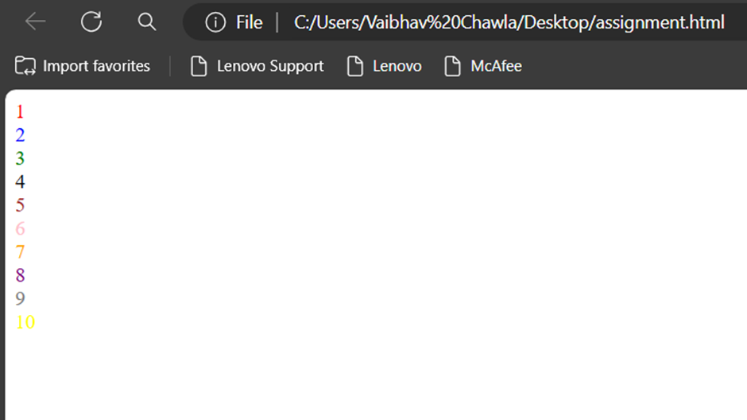

***Q5- how to make a picture as a background on my web pages?***

***<HTML>***

***<HEAD>***

***<TITLE> HELLO WORLD </TITLE>***

***</HEAD>***

***<body>***

***<body background="ai.jpeg">***

***</body>***

***</html>***

**Q6=Create a web page to print a paragraph with 4-5 sentences, each sentences shall have a different font?**

**<html>**

**<head>**

**<title> BCA IB </title>**

**</head>**

**<body>**

**<h1>Mukesh dagar </h1>**

**<P>**

**<B>My name is Mukesh dagar</B><br>**

**<I>I am Currently studing in manav rachna international institute of research and science. It is situated in**

**jharsently, Faridabad. </I>**

**<br> <U> My course that i am pursuing right now is BCA(AI/ML) </U>.**

**<br><B> My Hobbies are playing games and watching movies and sometimes i go to play**

**basketball with My friends.</B><br>**

**</p>**

**</body>**

**</html>**

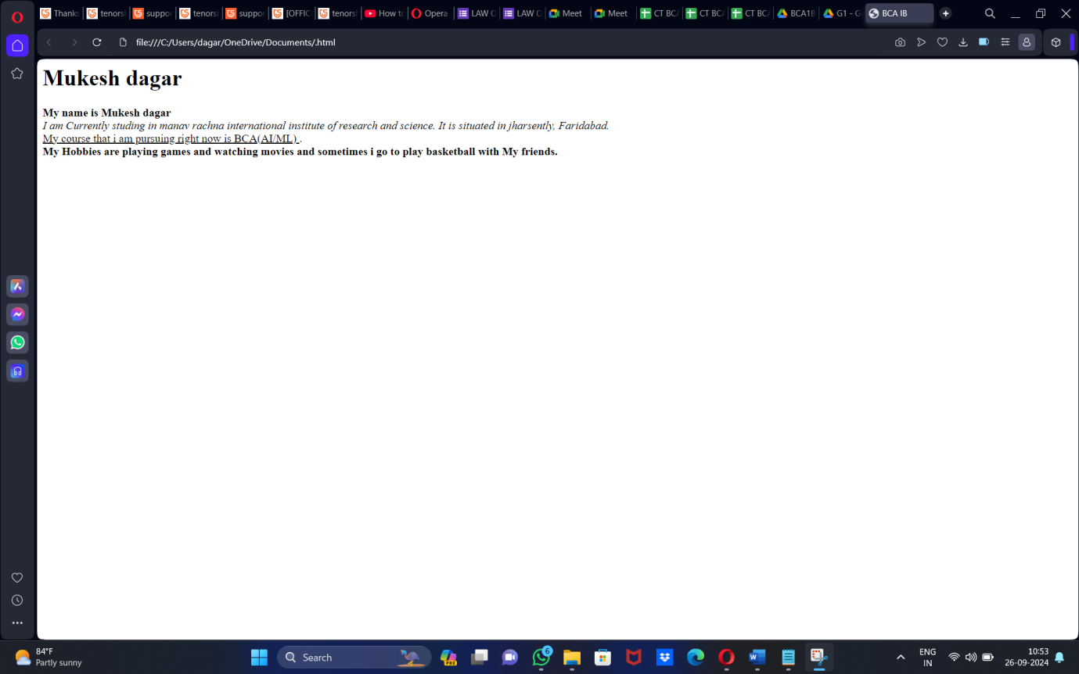

**Q7=write HTML code to print a paragraph that is described of a book, it shall include the title should be underlined and all adjectives shall be bold and italics?**

**<HTML>**

**<HEAD>**

**<TITLE>BOOK </title>**

**</head>**

**<Body>**

**<H1><u><b> Title Of The Book: marvel spiderman</b></u></H1>**

**<p><i> Author Name: roy thomas <br></i>**

**<i>Harry Potter is a series of novels by British author roy thomas The novels follow marvel spiderman,**

**an 11-year-old boy who discovers he is the son of famous wizards and will attend Hogwarts School of Witchcraft and Wizardry.**

**Harry learns of an entire society of wizards and witches. He befriends several Hogwarts students and teachers along his journey.**

**Each novel chronicles one year in Harry's life and**

**his adventures discovering the events that led to his parents' deaths at the hands of Lord Voldermort, a dark wizard believed long dead.</i></P>**

**</p>**

**</body>**

**</html>**

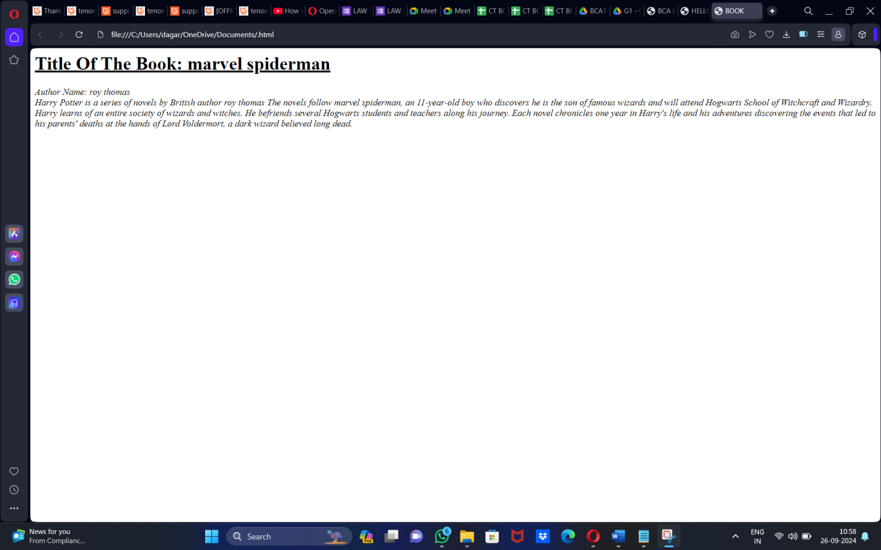

**Q8: Write HTML code to print your name using heading tag, every letter shall be of different heading size?**

**<HTML>**

**<HEAD>**

**<Title> Krish </Title>**

**</HEAD>**

**<BODY>**

**<H1> A</h1>**

**<H2> B</h2>**

**<H3> C</h3>**

**<H4> D</h4><br>**

**<H5> E</h5>**

**<H6> F</h6>**

**<H1> G</h1>**

**<H2> H</h2>**

**</body>**

**</html>**

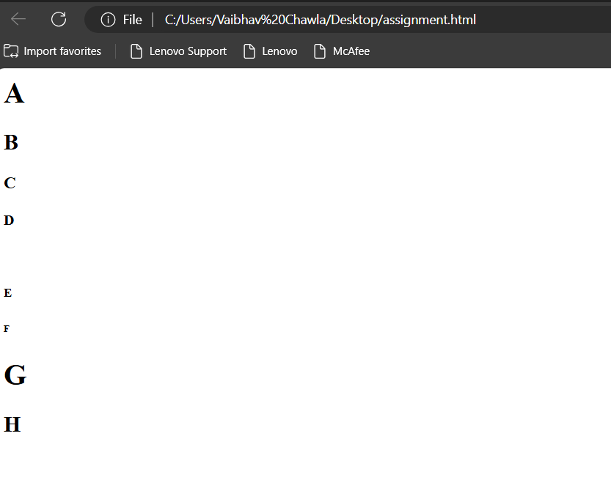

Q9. Write HTML code to print the sequence of numbers 1 – 20. Each number shall be in a different line

with number 2 next to it as subscript, an equal sign and the result.

Input:

<html>

<head>

<title> number sequence</title>

</head>

<body>

<p>1<sub>2</sub> = 2</p>

<p>2<sub>2</sub> = 4</p>

<p>3<sub>2</sub> = 6</p>

<p>4<sub>2</sub> = 8</p>

<p>5<sub>2</sub> = 10</p>

<p>6<sub>2</sub> = 12</p>

<p>7<sub>2</sub> =14</p>

<p>8<sub>2</sub> = 16</p>

<p>9<sub>2</sub> = 18</p>

<p>10<sub>2</sub> = 20</p>

<p>11<sub>2</sub> = 22</p>

<p>12<sub>2</sub> = 24</p>

<p>13<sub>2</sub> = 26</p>

<p>14<sub>2</sub> =28</p>

<p>15<sub>2</sub> = 30</p>

<p>16<sub>2</sub> = 32</p>

<p>17<sub>2</sub> = 34</p>

<p>18<sub>2</sub> = 36</p>

<title> number sequence</title>

</head>

</body>

</html>

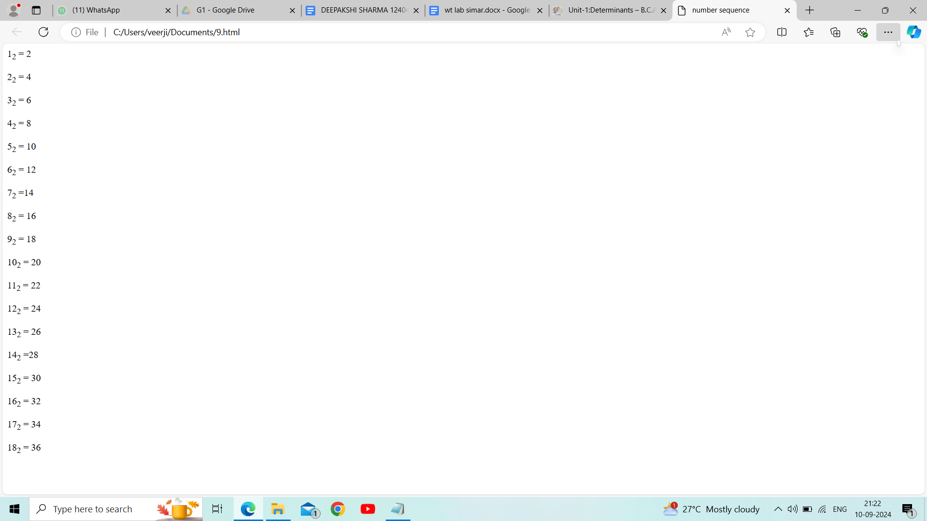

**Q10.** Write HTML code to display an image with border of size with width 200, height 200 pixel, leaving H space and V space of your choice with image hanging in the right side on the screen.

**Ans. <HTML>**

**<HEAD>**

**<TITLE>INTRODUCTION</TITLE>**

**<style>**

**img{**

**border:2px solid black;**

**width:400px;**

**height:500px;**

**display:block;**

**margin-left:auto;**

**margin-right:0;**

**margin-top:40px;**

**margin-bottom:50px;**

**</style>**

**</HEAD>**

**<BODY>**

**<img src="C:\Users\simar\Pictures\Screenshots/display.jpg"**

**alt="sample image">**

**</BODY>**

**</HTML>**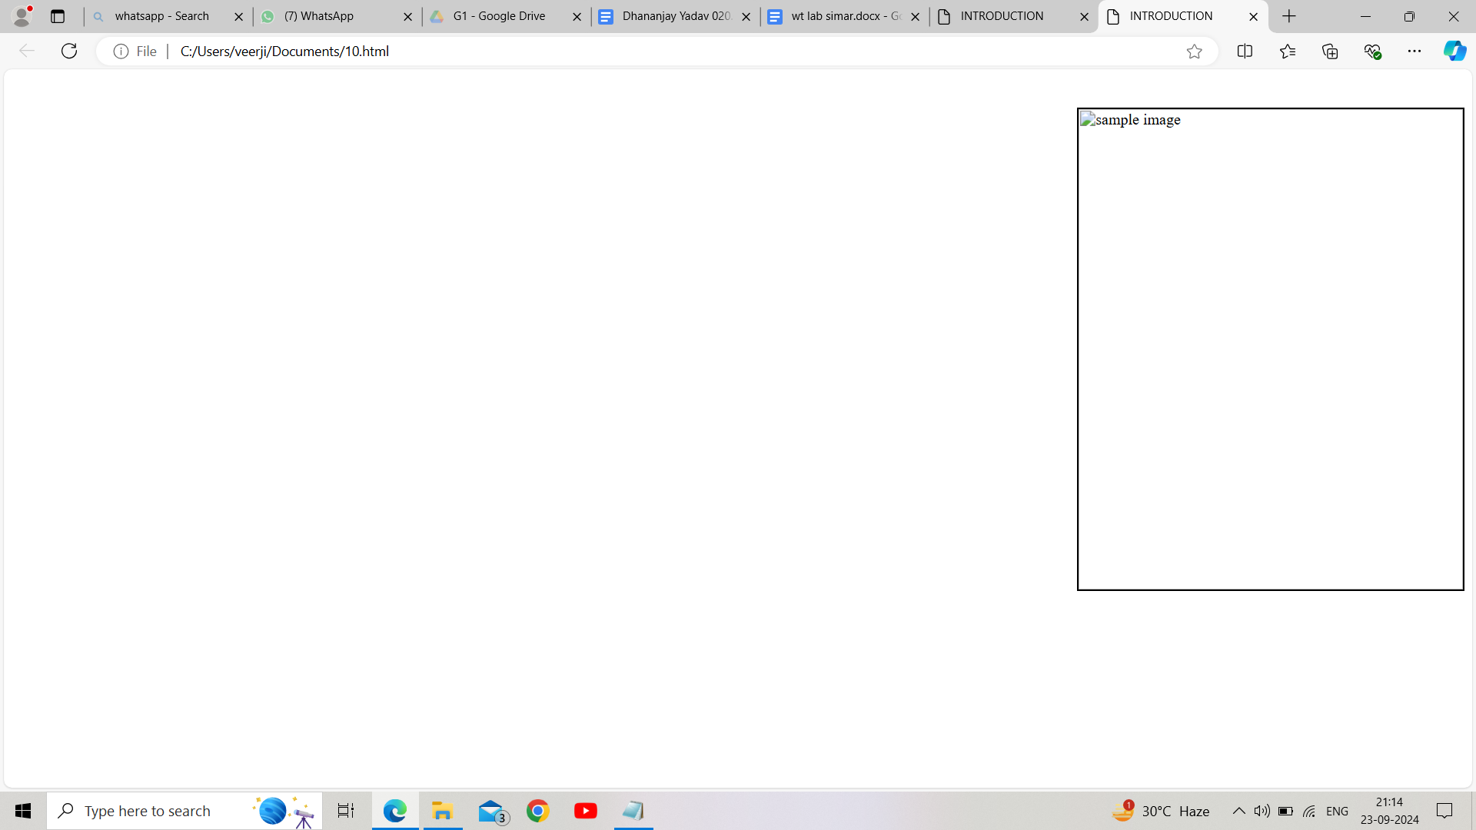

**Q11.** Write HTML code to create a web page with heading. The heading shall be displayed at the top-center of the page and the image shall be at the center, just below the heading.

**Ans. <HTML>**

**<HEAD>**

**<TITLE>INTRODUCTION</TITLE>**

**<style>**

**body{**

**margin:0;**

**font-family:arial, sans-serif;**

**text-align:center;**

**justify-content:center;**

**align-items:center;**

**</style>**

**</head>**

**<body>**

**<h1>diwali 2024</h1>**

**<img src="C:\Users\MUKESH DAGAR\OneDrive\Pictures/festival.jpg"**

**alt="FESTIVAL CELEBRATION">**

**</BODY>**

**</HTML>**

**OUTPUT –** 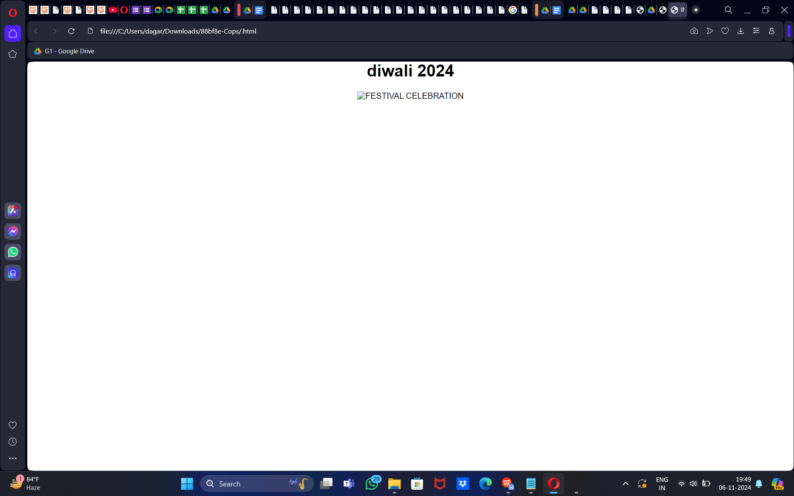

**Q12.** Write HTML code using Multimedia tags.

**Ans. <HTML>**

**<HEAD>**

**<TITLE>MULTIMEDIA TAGS</TITLE>**

**</head>**

**<body>**

**<h1 align="center">MULTIMEDIA</H1>**

**<hr>**

**<video src="C:\Users\simar\OneDrive\Pictures/moon.mp4" controls="controls" width="820" height="520">**

**</video>**

**<br>**

**<audio src="C:\Users\simar\OneDrive\Pictures/moon.mp3" controls="controls" autoplay="autoplay">**

**<embed src="name.pdf" width="px" height="px">**

**<object data="file.name" width="px" height="px">**

**</object>**

**</BODY>**

**</HTML>**

**OUTPUT –**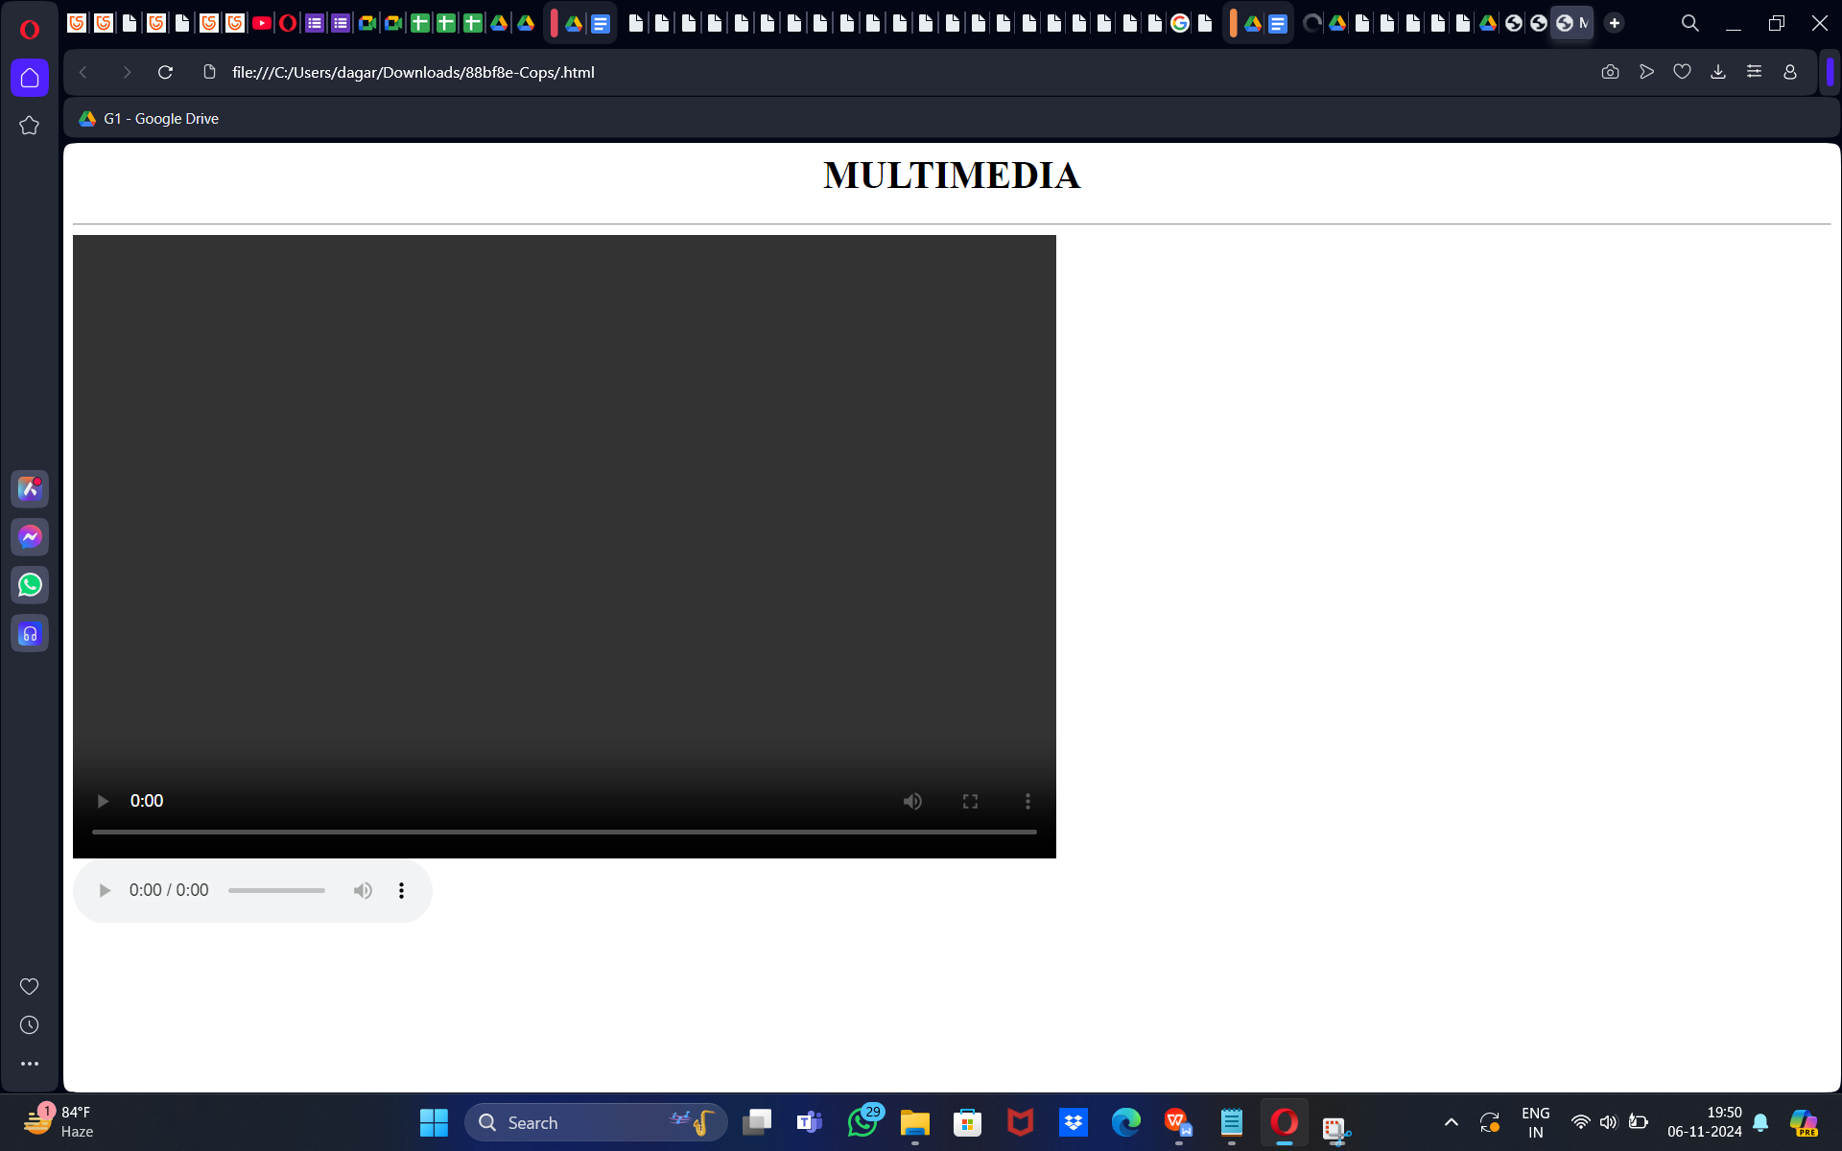

**13: Create a Table using Rowspan and Colspan taking example of**

**student Record?**

**Ans:**

**<html>**

**<head>**

**<title> my world </title>**

**</head>**

**<table>**

**<tr>**

**<th colspan="2">Name</th>**

**<th>Age</th>**

**</tr>**

**<tr>**

**<td>jack</td>**

**<td>Smith</td>**

**<td>26</td>**

**</tr>**

**<tr>**

**<td>Elvee</td>**

**<td>yourn</td>**

**<td>28</td>**

**</tr>**

**</table>**

</body>

</html>

# 

### 14.Write HTML code using table tag and cellpadding and cell spacing as its attributes.

### <html>

### <head></head>

### <body>

### <table border="2pt" cellspacing="5pt" cellpadding="5pt">

### <tr>

### <th>S.no</th>

### <th>Roll no.</th>

### <th>Name</th>

### <th>Address</th></tr>

### <tr>

### <td>1</td>

### <td>123</td>

### <td>ABC</td>

### <td>FBD</td></tr>

### <tr>

### <td>2</td>

### <td>456</td>

<td>xyz</td>

<td>gurgaon</td></tr>

<tr>

<td>3</td>

<td>789</td>

<td>pqr</td>

<td>palwal</td>

</table>

</body>

</html>

### 

Q15. Create unordered, ordered and definition Lists taking example of your subjects in MCA IST, IInd and IIIrd Semester. Input :

Input :

<html>

<head></head>

<body>

<h3> Subjects in BCA sem 1</h3>

<ol>

<li>Web technologies</li>

<ul>

<li>introduction to Networks</li>

<li>introduction to e-mail</li>

<li>introduction to html</li>

</ul>

<li>Introduction to IT & programming in C</li>

<ul>

<li>Input output devices</li>

<li>compilers,Interpreters,assemblers</li>

<li>various programs in c </li>

</ul>

<li>mathematics</li>

<ul>

<li>matrices</li>

<li>surds and insurdes</li>

</body>

</html>

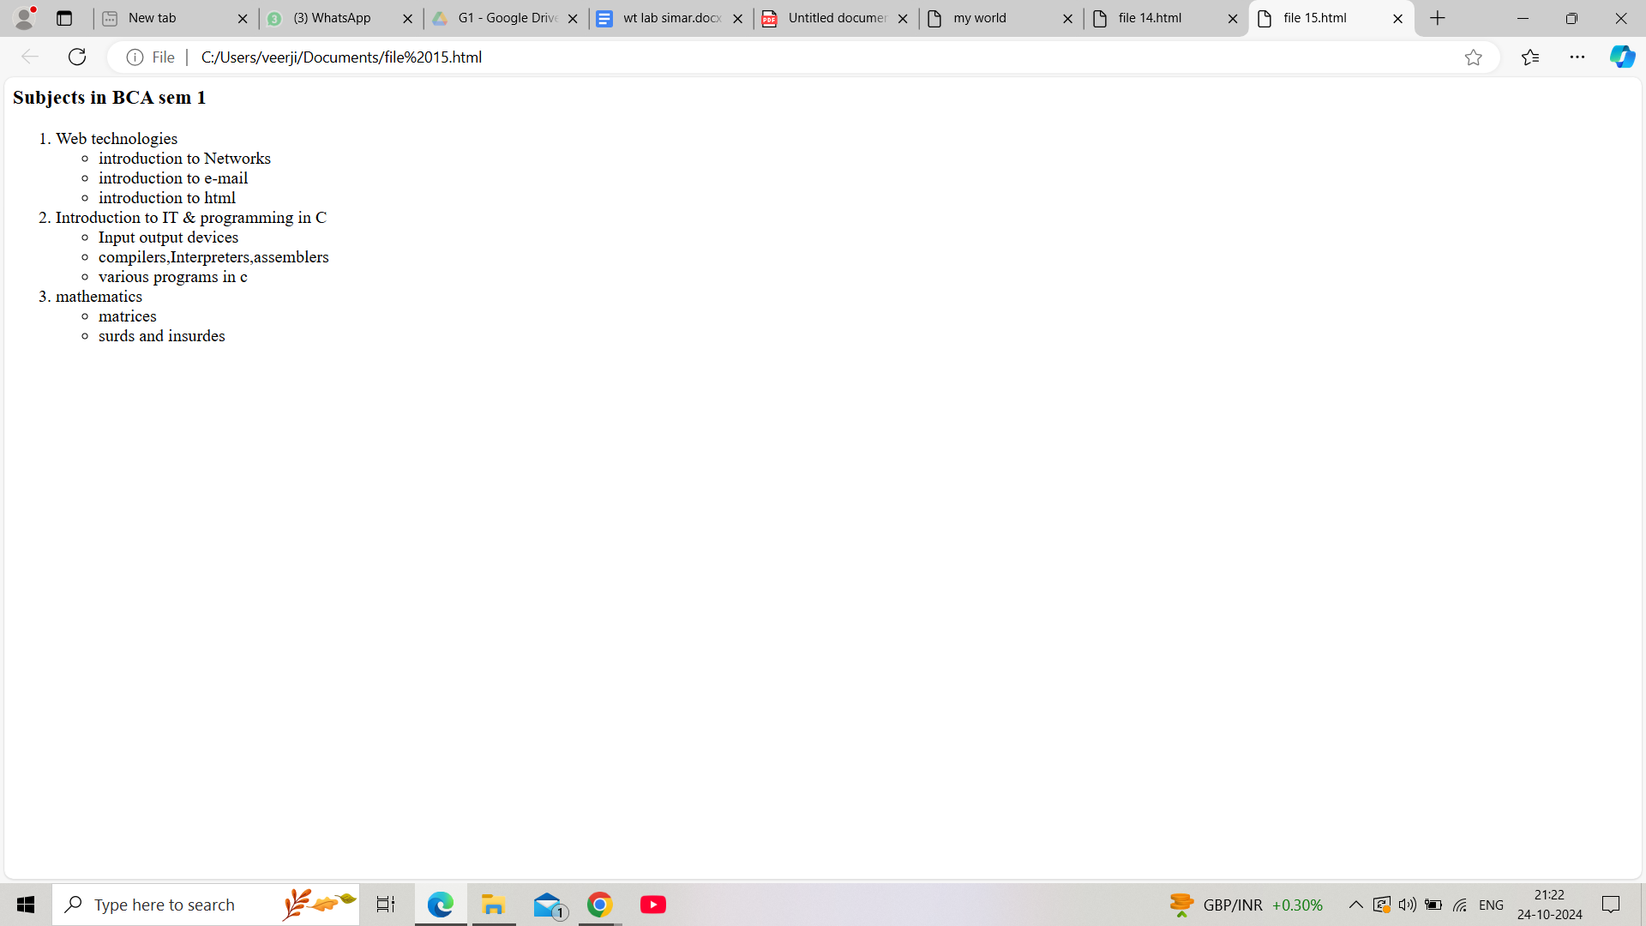

16.Write HTML code using<frame set> and <frame>tag with all its attributes .

<**html**>

<**head**>

<**title**>frameset attribute</**title**>

</**head**>

<**body**>

<**frameset** cols="30%, 40%, 30%">

<**frame** name="top" src="attr1.png" />

<**frame** name="main" src="gradient3.png" />

<**html**>

<**head**>

<**title**>frameset attribute</**title**>

</**head**>

<**body**>

<**frameset** cols="30%, 40%, 30%">

<**frame** name="top" src="attr1.png" />

<**frame** name="main" src="gradient3.png" />

<**frame** name="bottom" src="col_last.png" />

<**noframes**>

<**body**>The browser you are working does

not support frames.</**body**>

</**noframes**>

</**frameset**>

</**body**>

</**html**>

Q17Write HTML code to design a form in HTML using controls and buttons such as Teaxtbox, Textarea, password, submit button, browse button, drop-down menu?

<html>

<head>

<title> Form </title>

<head>

<body>

<h2>form</h2>

<form>

<fieldset>

<legend><font color=”red”size =”5” face =”arial”><b>COLLEGE

FORM</b></font></legend>

<label for =”fname” id=name><b>name:</label></br>

<input type=”text” required/>

<label for="fname" id=name><b>Name:</label><br>

<input type="text" required/>

<label for="12th Marks" id="name"><b> 12th Marks(%):</b></label>

<input type="number" max="100" min="33" required/>

<b> Upload here</b>

<input type="file"/><br>

<label for="Email" id=name required>Email:</label><br>

<input type="Email"/>

<label for="10th Marks" id="name" required ><b>10th

Marks(%):</b></label>

<input type="number" max="100" min="33"/>

<b> Upload here</b>

<input type="file" name="mark sheet"/><br>

<label for="Name" id=name>Father's Name:</label><br>

<input type="text"/>

<font color="red">Charactor certificate</font>

<input type="file" required/><br>

<label for="Course Name" id=name>Course Name:</label><br

<input type="text"/>

<font color="red">Migration certificate</font>

<input type="file"/><br><br>

<b>Phone No:</b>

<input type="text" size="9" maxlength="10" required/>

<hr>

<b><font size="2" color="red" face="arial"><u>

gender</u></font></b><br>

<input type="radio" name="gender"/>

<label for="gender" name="gender">Male</label>

<input type="radio" name="gender"/>

<label for="gender" name="gender">female</label>

<input type =”radio” name=”gender”/>

<label for=”gender” name =”gender”>others </label><br>

<b><font size="2" color="red" face="arial"

><u>Subject</u></font></b><br>

<input type="Checkbox"/>

<label for="Subject" name="subject">Wt</label>

<input type="Checkbox"/>

<label for="Subject" name="subject">Dbms</label>

<input type="Checkbox"/>

<label for="Subject" name="subject">ITPC</label>

<input type="Checkbox"/>

<label for="Subject" name="subject">Eng</label>

<input type="Checkbox"/>

<label for="Subject" name="subject">History</label><br>

<font color="red" size="2" face="arial"><u>Section</u></font>

<select id="section" name="section" required>

<option value="A">A</option>

<option value="B" selected>B</option>

<option value="C">C</option>

<option value="D">D</option>

</select>

<hr>

<lable for="date" name="birth">DOB:</lable>

<input type="date" max="2007" min="2003" required/><br><br>

<lable for “date” name=”birth”>date of joining </table>

<input type =”month’ id = “joining” required/><br>

<br>

<input type = “image” height =”90” width =”400” align =”right”

<button >submit</button>

<button> cancel<button>

</fieldset>

</form>

</body>

</html>

OUTPUT:

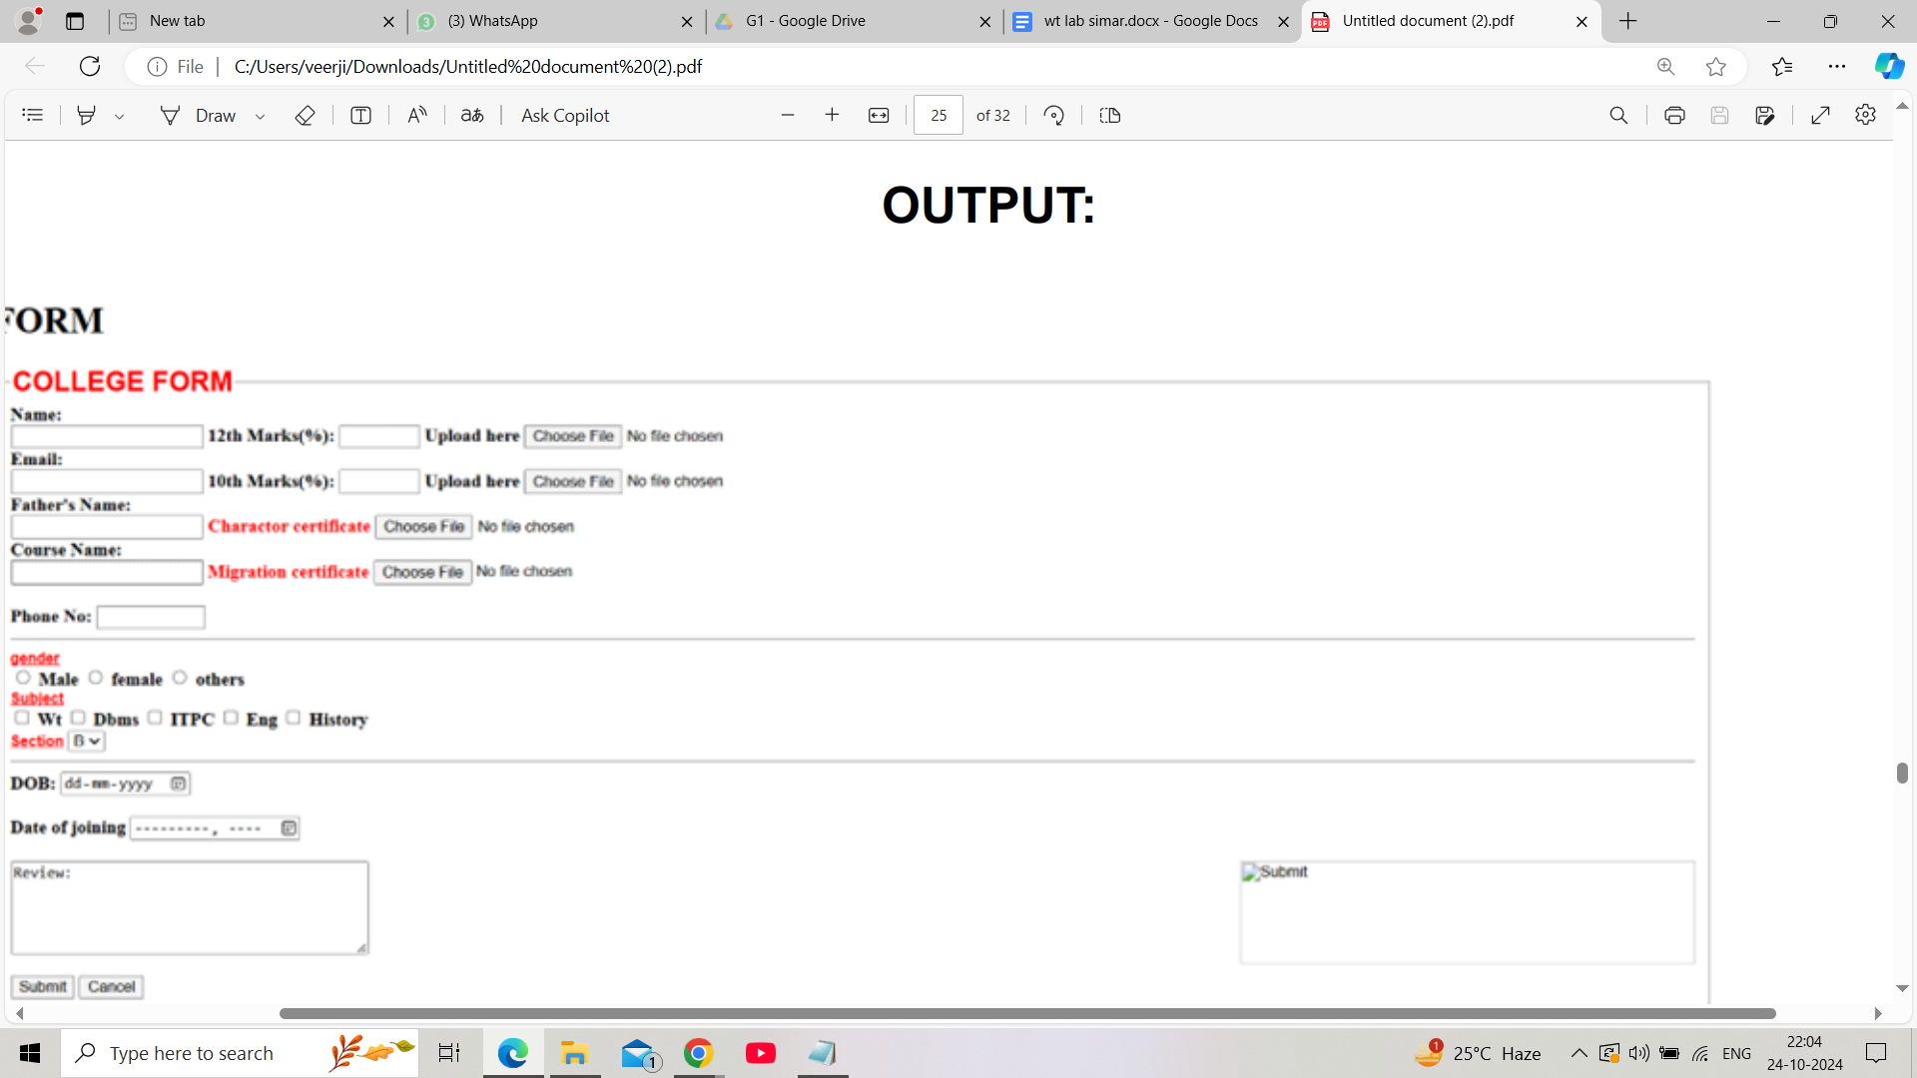

Q18. Write HTML code to design a Registration Form in HTML. Input:

Input:

<!DOCTYPE html>

<html>

<head>

<title>Grade Volleyball Registration Form</title>

</head>

<body>

<h1>Grade Volleyball Registration Form</h1>

<form action="submit.php" method="post">

<label for="first_name">Participant Name</label><br>

<input type="text" id="first_name" name="first_name"

placeholder="First"><br>

<input type="text" name="last_name"

placeholder="Last"><br><br>

<label for="age">Age</label><br>

<input type="number" id="age" name="age"><br><br

<label for="grade">Grade</label><br>

<select id="grade" name="grade">

<option value="">Please select</option>

<option value="1">1</option>

<option value="2">2</option>

</select><br><br>

<label for="school_district">School District</label><br>

<input type="text" id="school_district"

name="school_district"><br><br>

<label for="shirt_size">Shirt Size</label><br>

<select id="shirt_size" name="shirt_size">

<option value="">Please select</option>

<option value="s">Small</option>

<option value="m">Medium</option>

<option value="l">Large</option>

<option value="xl">Extra Large</option>

</select><br><br>

<label for="parent_first_name">Parent Name</label><br>

<input type="text" id="parent_first_name"

name="parent_first_name" placeholder="First"><br>

<input type="text" name="parent_last_name"

placeholder="Last"><br><br>

<label for="emergency_contact">Emergency Contact </label><br>

<input type="text" id="emergency_contact"

name="emergency_contact"><br><br>

<inpuytype="submit" value="Submit">

</form>

</body>

</html>

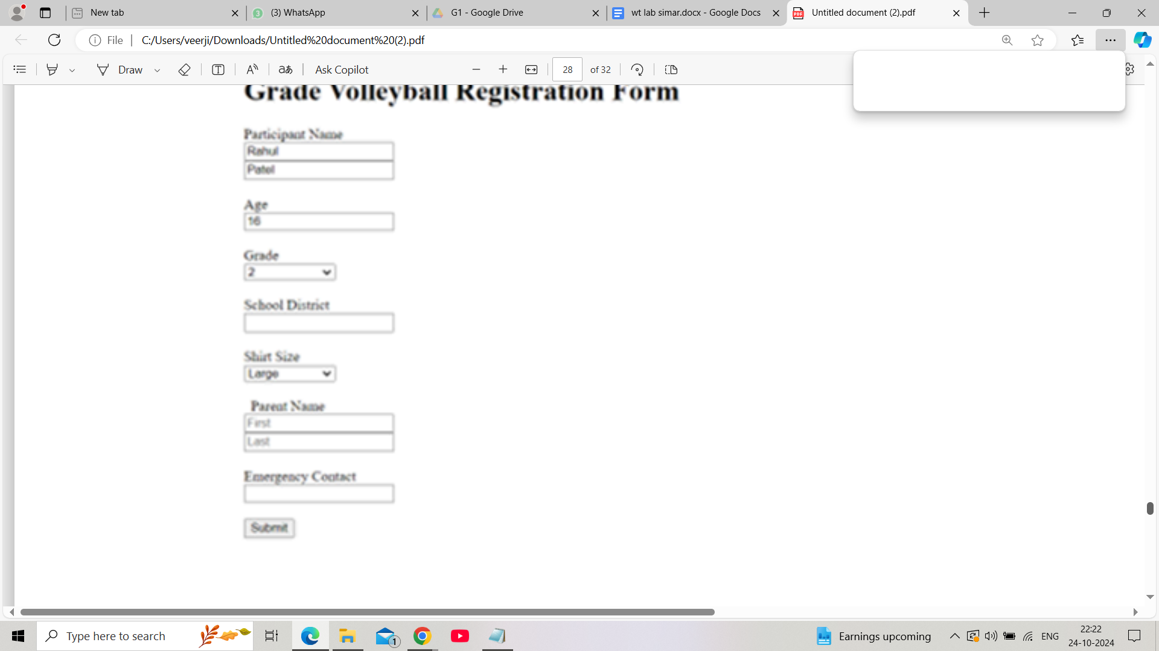

Q19. Write HTML code to design a student admission Form in HTML.

Input:

<!DOCTYPE html>

<html>

<head>

<title>Student Admission Form</title>

</head>

<body>

<h1>Student Admission Form</h1>

<form action="submit.php" method="post">

<label for="student_name">Student Name</label><br>

<input type="text" id="student_name" name="student_name"

required><br><br>

<label for="date_of_birth">Date of Birth</label><br>

<input type="date" id="date_of_birth" name="date_of_birth"

required><br><br>

<label

for="gender">Gender</label><br>

<input type="radio" id="male" name="gender" value="male">

<label for="male">Male</label>

<input type="radio" id="female"

name="gender" value="female">

<label for="female">Female</label><br><br>

<label for="address">Address</label><br>

<textarea id="address" name="address"

rows="5" cols="30" required></textarea><br><br>

<label for="phone_number">Phone Number</label><br>

<input type="tel" id="phone_number" name="phone_number"

required><br><br>

<label for="email">Email</label><br>

<input type="email" id="email" name="email" required><br><br>

<label for="class">Class</label><br>

<select id="class" name="class" required>

<option value="">Please select</option>

<option value="1">1</option>

<option value="2">2</option>

</select><br><br>

<label for="guardian_name">Guardian Name</label><br>

<input type="text" id="guardian_name" name="guardian_name

required><br><br>

<label for="guardian_contact">Guardian Contact</label><br>

<input type="tel" id="guardian_contact" name="guardian_contact"

required><br><BR>

<inputtype=”submit” value=”submit”>

</form>

</body>

</html>

Output;

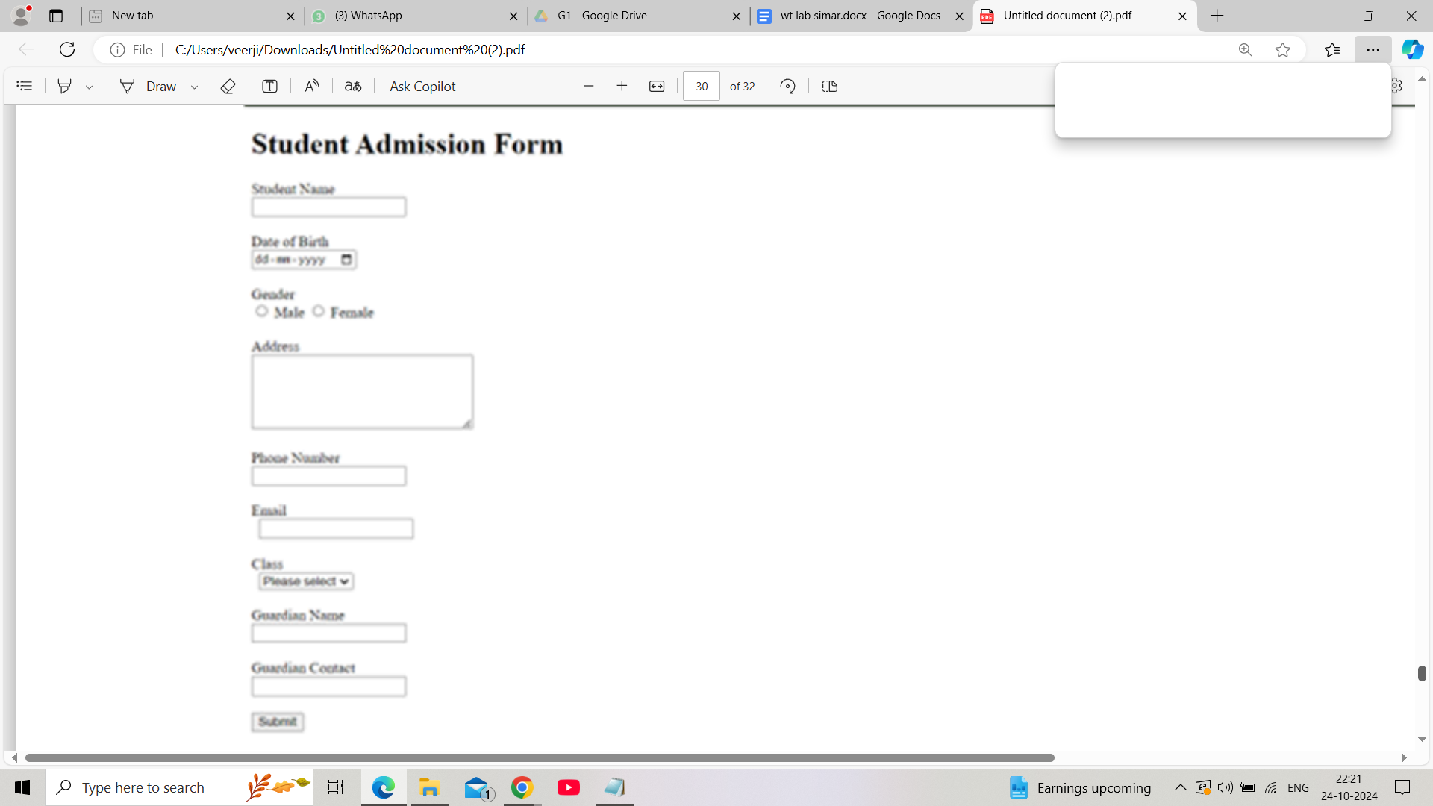

20. Create a proper home page of your own using any components

and styles.

Input:

<!DOCTYPE html>

<html>

<head>

<title>My Personal Website</title>

<link rel="stylesheet" href="styles.css">

</head>

<body>

<header>

<h1>My Name</h1>

<nav>

<ul>

<li><a href="index.html">Home</a></li>

<li><z href =”projects.html”>projects</a></li>

<li>a href =”contact.html”>contact</a><LI>

</ul>

</nav>

</header>

<main>

<section>

<h2>Welcome to My

Website!</h2>

<p>This is a brief introduction about myself. Feel free to explore

my projects and contact .</p>

<img src =”profile_pic.jpg”alt =”profile picture”>

</section>

<main>

<footer>

<p>&copy;2023 my name </p>

</footer>

</body>

</html>

